ROCHE BROS (S.A.) PTY. LTD.
Excavation and Engineering
Registered Office
827 Port Road, Woodville, S.A. 5011
Telephone
45 7865
12 March 1980
President,
Gwala [sic] Daraniki Association Inc.,
Kulaluk,
DARWIN, N.T. 5790

Attention : Bobby Secretary
Albert Treeves [sic]

Dear Sirs,

Re : STOCKPILE KULALUK

We confirm your agreement to our request to provide filling from your land west of the new Fannie Bay – Nightcliff Connector Road and approximately opposite Fitzer Drive (chainage 2,300M to 2,700M on the new road).

It is understood we will leave the area excavated in a clean and tidy manner, free draining graded towards the sea.

We will pay your Association 25 cents per cubic metre for all material removed.
Before commencing work we will have the area surveyed and again after completion so that quantities can be calculated.

This agreement is conditional on the Department of Transport & Works giving approval for the material to be used in the new road and allowing us to take it from your property.

We will pay a deposit of $250 into your association Account before we commence work and the balance when the work is completed.

Approximately 6.000 to 8,000 cubic metres is expected to be required.

We trust this agreement will be to our mutual benefit.

Yours faithfully, ROCHE BROS (S.A.) PTY LTD
(signed) R.F.BACON
GENERAL MANAGER

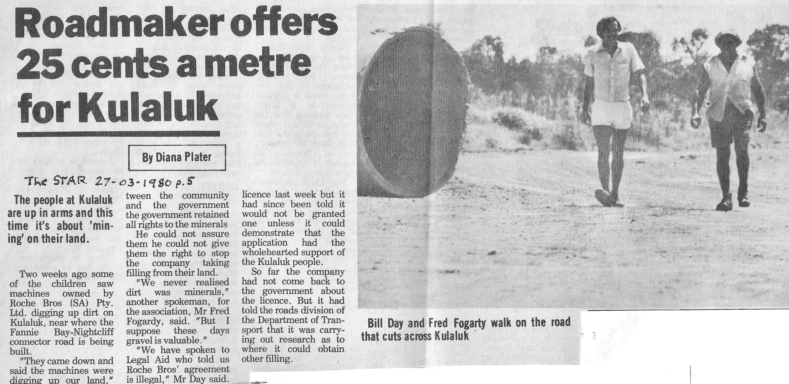
ROADMAKER OFFERS 25 CENTS A METRE FOR KULALUK.
The Darwin Star, 27 March 1980, page 5.
By Diana Plater (her article has been abbreviated)

The people of Kulaluk are up in arms and this time it's about 'mining' on their land.
Two weeks ago some of the children saw machines owned by Roche Bros (SA) Pty Ltd digging up dirt on Kulaluk, near where the Fannie Bay–Nightcliff connector road is being built.
“They came down and said the machines were digging up our land,” a spokesman for the Gwalwa Daraniki Association, Mr Bill Day, said.
The contracting company had approached two members of the Association and asked them to sign an agreement. The agreement said the company would pay the Association 25 cents a metre for all material removed from land on Kulaluk west of the new road...
“Roche Brothers took the easy course,” Mr Day said. “They would be paying 25 cents a metre whereas it would have cost them $5 to cart it from somewhere else... When we heard we went back to all the people. Only two people signed the agreement. [Roche Bros] were working for two days before we got the Mines Branch to stop it... We have spoken to Legal Aid who told us Roche Brothers' agreement is illegal... They give land and then they come in and take it back,” Mr Day said. “We're saying get your hands off Kulaluk once and for all.”
In the meantime, according to the manager of Roche Bros, Mr M. Johnson, the company was “waiting for the gods.”
“We approached the association and made a request,” he said. “We entered into an agreement which other people have got involved in. If we don't get the filling from Kulaluk goodness knows where we'll get it from. We're only the contractors doing the job,” Mr Johnson said.
A spokesman for the Minister for Transport and Works, Mr [Roger] Steele, said Roche Bros had been told to stop using filling from Kulaluk and to try to find filling somewhere else in the Darwin area. The spokesman said for the company to take filling from Kulaluk it would have needed an extraction license. The company applied for a licence last week but it had since been told it would not be granted one unless it could demonstrate that the application had the wholehearted support of the Kulaluk people.

